Name _____________________________________________ ________________/70 points
Alien/Monster Poster in Photoshop
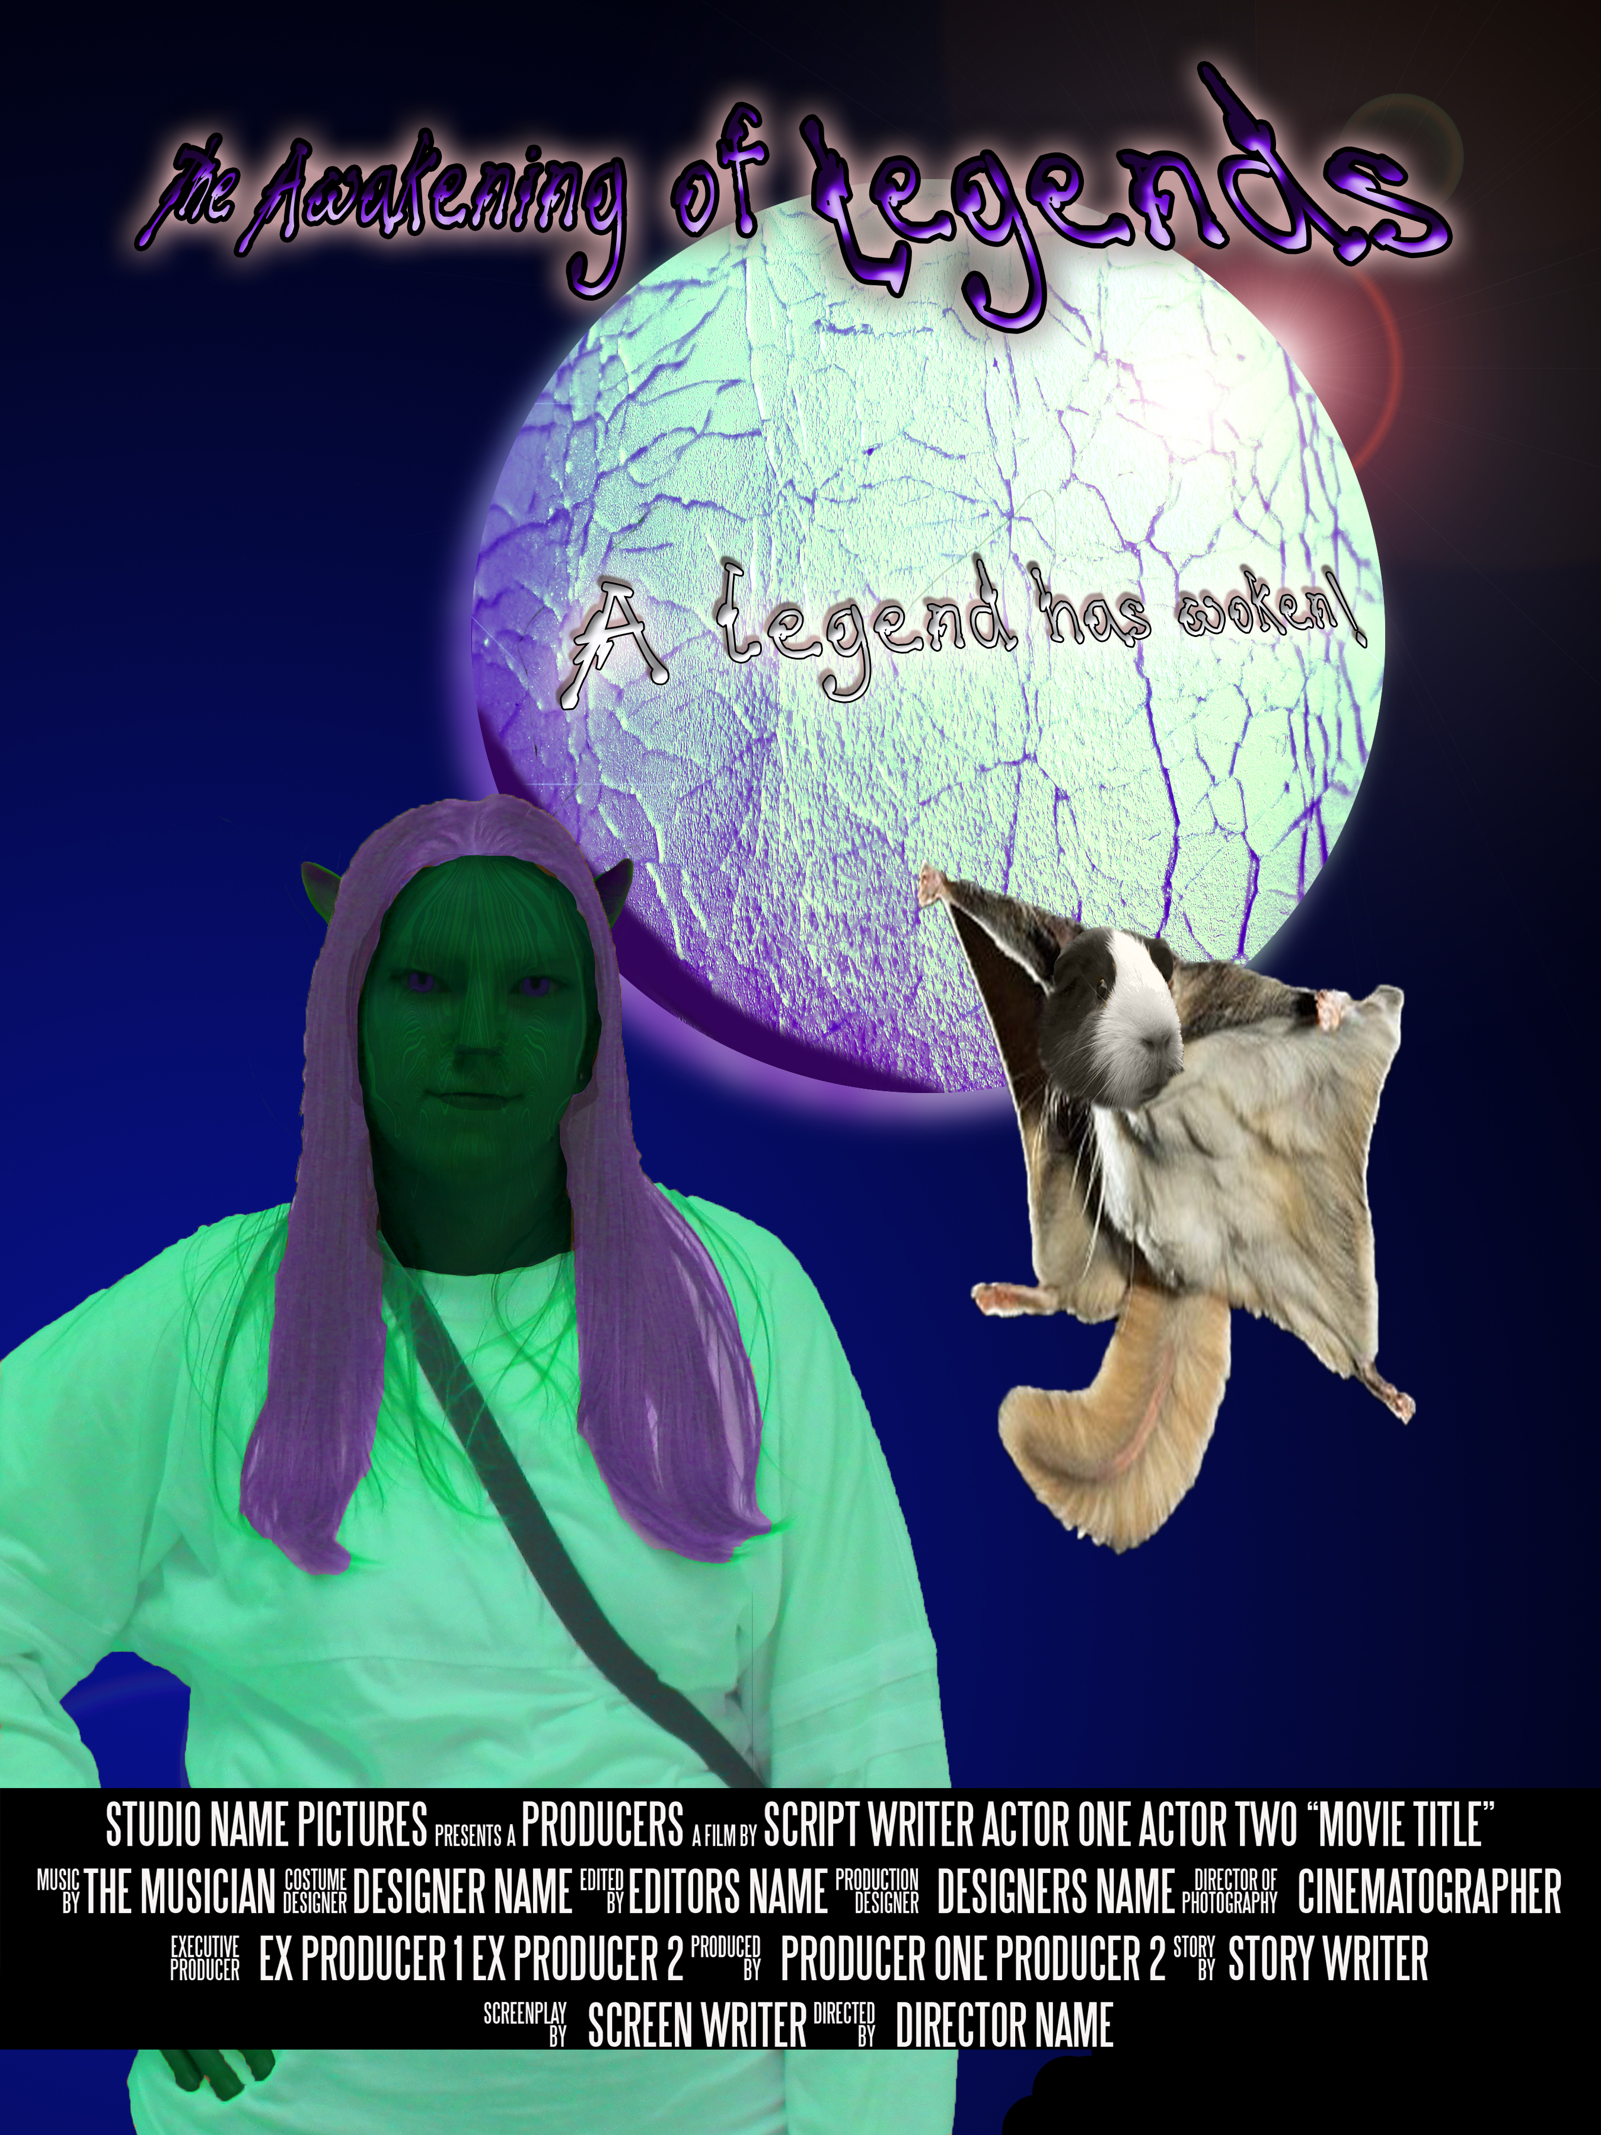
WHAT YOU ARE DOING!
You are going to make a poster that is about an Alien/Monster Movie---
YOU are the Monster/alien…Copy Movie Poster Folder from Shared Digital Design Folder and add Your last name first initial to beginning. Also install the font provided this will be used for the credits.

Your challenge is to create a poster for a Movie and to bring to life films that doesn’t actually exist! It is about an Alien or Monster…YOU!!!

✓ Movie Title
✓ Tagline
✓ Credits (use font provided)
✓ Rating (ie PG13)
✓ Alien
✓ Original Background

✓ Your own object (Planet, Spaceship, etc)
✓Your own pet

The poster cannot contain images from online unless they are 90% edited.

You are the director… That is where your name will go.

GETTING STARTED!
✓ Download from Shared-Folder Movie Poster add your Name: YourLastnamefirstinital MoviePoster
✓Install the font that is supplied (SteelTongs)
✓Open Indesign Movie Poster and Verify >The size of the poster Print 18”x 24” .125” bleed and .25” margin.
✓ In Photoshop
- FileName: Monster or Alien- Paste your picture into a new layer—duplicate it so you have original if you need to start over> Distort yourself (hair color, skincolor/texture/ liquify/ears, nose eyes etc.)
- FileName: Object. Make you own other image to incorporated—example: Planet, Spaceship etc.
- FileName: Background: Make your own background using brushes and/or any other effects you want to incorporate edited pictures ect.
- Filename: Unholy Creature You as an alien/Monster have a pet…it is the unholy of creatures> merge at least 2-3 images together using liquify/distortion etc. change color etc. It should be of high quality.

Back to your Indesign File: Come up with Name of Movie, a tagline and Complete Your Alien (you may need to complete your alien first to get inspiration. Be careful on font selection/size/Color and Effects.

For your Credits: Use the template provided in the folder in photoshop or use the layer already put into your InDesign D. You will need to replace with actual names. You must be the director…Which is the last credit

Look at rubric and go over before turning in.

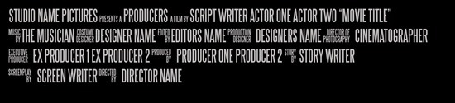
Print to Color Printer….and Turn in…Make sure layers are named… I should see tutorials easily…. You can hide them…but make sure they are named.

Name _______________________________________
Alien Poster

Grading: All will be graded on completeness, effort and time
Creation of Your Alien  This will be based on neatness, effectiveness, time and enhancements using some of the techniques in the listed tutorials. This will be a picture of you that you make yourself into an alien. Do you want a different pose? Make sure you transform your whole self, clean and creative. | 0-20 Points
Creation of Unholy creature. Must look effective. Clean cut and merged together effectively. Use liquify, masking distorting etc. Look at images before you start merging them. Make sure this is a high quality image not pixelated. | 0-10 Points
Own Background using brushes a Guide. Only use brushes to create your background…no downloaded images (Except to make brushes). May use brushezzy | 0-10 points
Another Photoshopped Piece (A building, a Planet, Spaceship,) Must be edited (I want to see the original Picture keep it in the layers panel) Change the color, add fire, smoke, something to change this. | 0-10 points
Credits- Open Credits.psd file YOU MUST BE DIRECTOR. All names must be changed people.. Effective placed and color etc. | 0-5 Points
Title and Tagline for the movie plus Rating (ex: Star Wars, In a Galaxy far far away… ) PG Use Some type of Type Transformation…(ie on path, transform, character panel, effects etc…. Do not just type this nor use default font and expect to get full credit.) Good Size and COLOR! | 0-5points
Creativity Time and effectiveness of Poster. Look at colors, readability, clarity effort and time you spent on this. Could you do something else to make it better if you have time… | 0-5 Points
Correct size Printed (Make sure you scale to fit before hitting print else it will be tooo big! Save Whole Folder to Handin> Make sure Layers named… Attach this rubric (-2 if no rubric) | 0-5 points

Attach this to back of your poster
Total 70 Points ______________________________/70

